GREENING BUSINESS
GUIDE - HAZARD PICTOGRAMS

Document information:
Activity result: | A5 Development of educational tools for greening businesses
Document type: | Training material
Responsible partner: | Centre for the Development of Jablanica and Pcinja Districts Leskovac, Serbia
Dissemination level: | Public

Document history:
Version | Date | Description /Comments | Author(s)
Version 1.0 | 04.02.2025. | Draft | - PMT
Version 2.0 |  | Final version | - PMT

Disclaimer:
Funded by the European Union. Views and opinions expressed are however those of the author(s) only and do not necessarily reflect those of the European Union or Foundation Tempus. Neither the European Union nor the granting authority can be held responsible for them.

Danger pictograms

The precautionary approach to chemicals management emphasizes the assessment of the hazards of chemicals, i.e. the classification of chemicals before they are placed on the market and informing users about their hazardous properties through labelling and safety data sheets, with the aim of protecting human health and the environment. Classification is carried out in accordance with the UN Globally Harmonized System of Classification and Labelling. In the process of classifying hazardous chemicals, labelling elements are assigned that correspond to the hazard class of the chemical, such as a graphic representation of the hazard (pictogram) and text indicating the hazardous properties of the chemical, which must be displayed on the label or packaging of the chemical in order to ensure that users of chemicals are adequately informed about the hazardous properties of the chemical.
Pictogram A hazard pictogram is a graphic representation of a hazard consisting of a pictorial symbol and other graphic elements such as a frame and background colour, which indicates information specific to the hazard in question.

 | Figure 1: Danger pictograms
Explosive chemicals | Flammable chemicals | Oxidizing chemicals
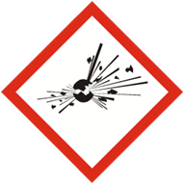  GHS01 | 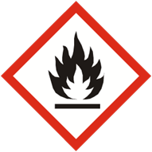  GHS02 | 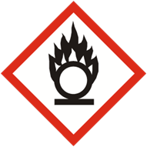  GHS03
Gases under pressure | Chemicals corrosive to metals and Chemicals causing corrosive damage to the skin | Acutely toxic chemicals
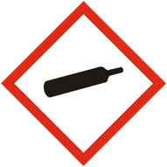  GHS04 | 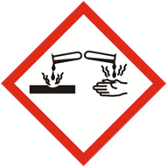  GHS05 | 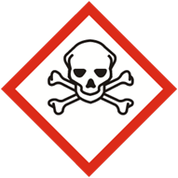  GHS06
Irritants, harmful chemicals and chemicals that can cause allergic skin reactions/chemicals that can damage the ozone layer | Chemicals that may cause damage to certain organs/allergic reactions of the respiratory system/carcinogenic, mutagenic and reprotoxic chemicals | Chemicals hazardous to the environment
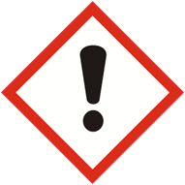  GHS07 | 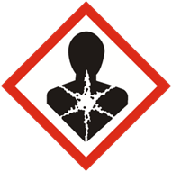  GHS08 | 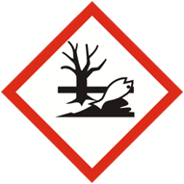  GHS09

Label elements such as a pictogram, text indicating the hazardous properties of the chemical and text indicating appropriate precautionary measures must be displayed on the label (packaging). In addition to these label elements, the name, address and telephone number of the supplier as well as the name and identification number of the chemical are also listed on the label. Hazard pictograms are the most visible part of the label. These pictograms refer to hazardous chemicals that have an impact on human health and the environment. From the perspective of greening the business of small and medium-sized enterprises (SMEs), it is crucial to consider the possibilities of replacing chemicals that have hazard pictograms on their labels with chemicals that are less toxic or not at all hazardous to human health and the environment. The best example is the use of cleaning agents in the form of detergents. The use of natural cleaning agents can avoid the purchase of detergents. In particular, vinegar or citric acid can be used to remove limescale deposits. A mixture of black tea and lemon juice is ideal for cleaning windows. You simply need to let a few tea bags sit for up to 10 minutes and mix them with squeezed lemon and 10 litters of warm water. Not only can windowpanes be cleaned without cleaning agents, but this mixture prevents the formation of dirt and ensures a long-lasting shine. Potatoes are ideal for cleaning stainless steel; just rub the steel with potatoes and the potato starch will do the rest. However, if you still need to buy cleaning agents, you should pay attention to whether the product has a hazard pictogram and, if possible, look for a similar product (of the same monetary value) that has an environmental label such as the EU Ecolabel.

 | □Avoid  Get□ | 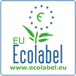

The EU Ecolabel encourages the implementation of a circular economy because its focus is on reducing negative impacts on the environment, extending the lifespan of products through appropriate eco-design of products, easy repair and servicing, while also considering the reduction or elimination of certain hazardous substances that enter the product's composition. The EU Ecolabel is the official voluntary label of the European Union for environmental excellence and is often called the EU Flower due to its visual identity. This label is world-renowned and is a voluntary scheme that promotes goods and services that clearly demonstrate environmental excellence, based on standardized processes and scientific evidence. Although it is voluntary, there are clear rules, regulations and procedures that a product must meet in order to obtain this label. So far, 98,977 products (goods and services) have been registered that have the EU Ecolabel. The list of these products is available on the EU Ecolabel E-catalogue. The access link is at the following address:

https://environment.ec.europa.eu/app/ecolabel-product-catalogue

Sources:

Ministry of Environmental Protection
https://www.ekologija.gov.rs/organizacija/sektori/sektor-za-upravlenje-zivotnom-sredin/informativni-pult-za-hemikalije-i-biocidne-proizvode/klasifikacija-pakovanje-obelezavanje-oglasavanje-hemikalia

Regulation on the classification, packaging, labelling and advertising of chemicals and certain products in accordance with the UN Globally Harmonized System of Classification and Labelling ("Official Gazette of the Republic of Serbia", No. 105 of 29 November 2013, 52 of 26 May 2017, 21 of 27 March 2019, 40 of 17 May 2023.)

EU Ecolabel
https://environment.ec.europa.eu/topics/circular-economy/eu-ecolabel_en

Fair Play: How to clean in the most environmentally friendly way possible
https://www.dm.rs/inspiracija-i-saveti/

